Unit 3 – Lesson 4
Poetry: I feel…poetry

In this lesson students will explore poetry with feeling. Students will be encouraged to explore poems with strong feelings and add feeling and emotion to their poetry.

Topic: Poetry

Time Frame: 60 minutes

Driving question: How can you add feeling to your poetry?

Curriculum Outcomes –
7: Students will be expected to use writing and other forms of representation including digital to explore, clarify and reflect on their thoughts feelings and experiences and learnings.
Learning Target:
Grade 1 | Grade 2
Write, using drawings, combination of letters with some sound associations and known words to explain feelings | Make decisions about word choice for specific reasons

Resources Needed:

- Collection of poetry books and poems
- Senses poem sample and graphic organizer
- Goal setting organizer
- Access to computers or iPads with familiar apps
- Writing Folder – to store writing at various stages
- Writer’s Notebook - to record ideas and goals for their writing

Lesson:

I Do:
Students should have an opportunity to interact with poetry. These should be on display in the classroom and explored during shared or independent reading experiences. It is an important step for growing writers to read good mentor texts.

Share poetry with strong feeling with the students. Talk about words that create feeling.
“When poet’s want to create a strong feeling, they describe what they feel, see, think, hear, smell, and taste. They use their senses to create a strong feeling. Let’s look at the poem “I Like It When It’s Mizzly” and see if the poet uses any of his or her senses to describe feeling.”
With student help, highlight feeling or senses words. Ask students to describe words or phrases that puts a strong image in their mind.

We Do:
Sense Poem Activity
Pop popcorn, cut an apple, or prepare any other food item that will appeal to all of the sense (keeping in mind school food policies and allergies). Have students fill out the senses poem graphic organizer. Have students compare their organizers. Are there similarities? Are there differences? Why might that be?

You Do:
Students should spend time independently writing. Students should choose a topic that they feel strongly about and spend time drawing and writing about it. Encourage students to think about the five senses. Are there elements of the sense in their poem? Have they described what they feel, see, hear, smell, or taste?
As students are independently writing it will be important to conference with students one-on-one or in small groups. Students can use the graphic organizer to help them brainstorm ideas during the writing process.

We Share:
When students are finishing up we can gather together as a group. Students can have an opportunity to share their writing they completed independently. Remind students that poetry may be about many different things and usually have a strong feeling or emotion attached to them. Encourage students to give one another feedback about the use of the senses in their poetry. Revisit the poetry rubric to see if we can identify areas of strength and areas of growth.

Extension:
There is a power point activity on creating a poem with strong feeling. This can be done in small groups as an extension or individually.

Extension Activity

Differentiation/Adaptations:
This is embedded into the design of the lesson plan. Students who use an iPad for writing or as a documented adaptation will easily be able to complete this assignment on any app of their choice.

Assessments:
Record observations on students’ poetry skills in Evernote or however you choose to track your students.
Students can revisit the goal-setting sheet and evaluate if they have achieved their goal and to set another goal.

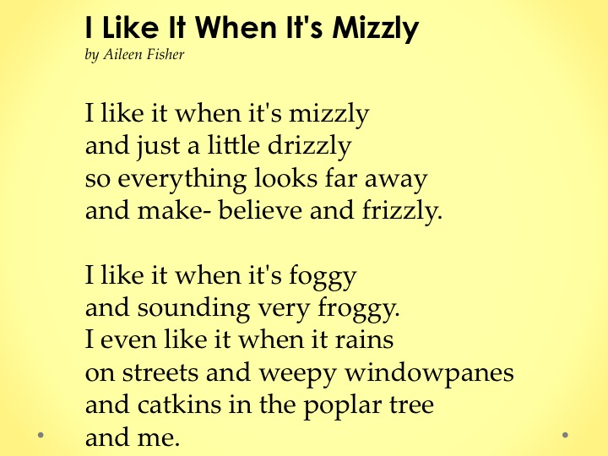
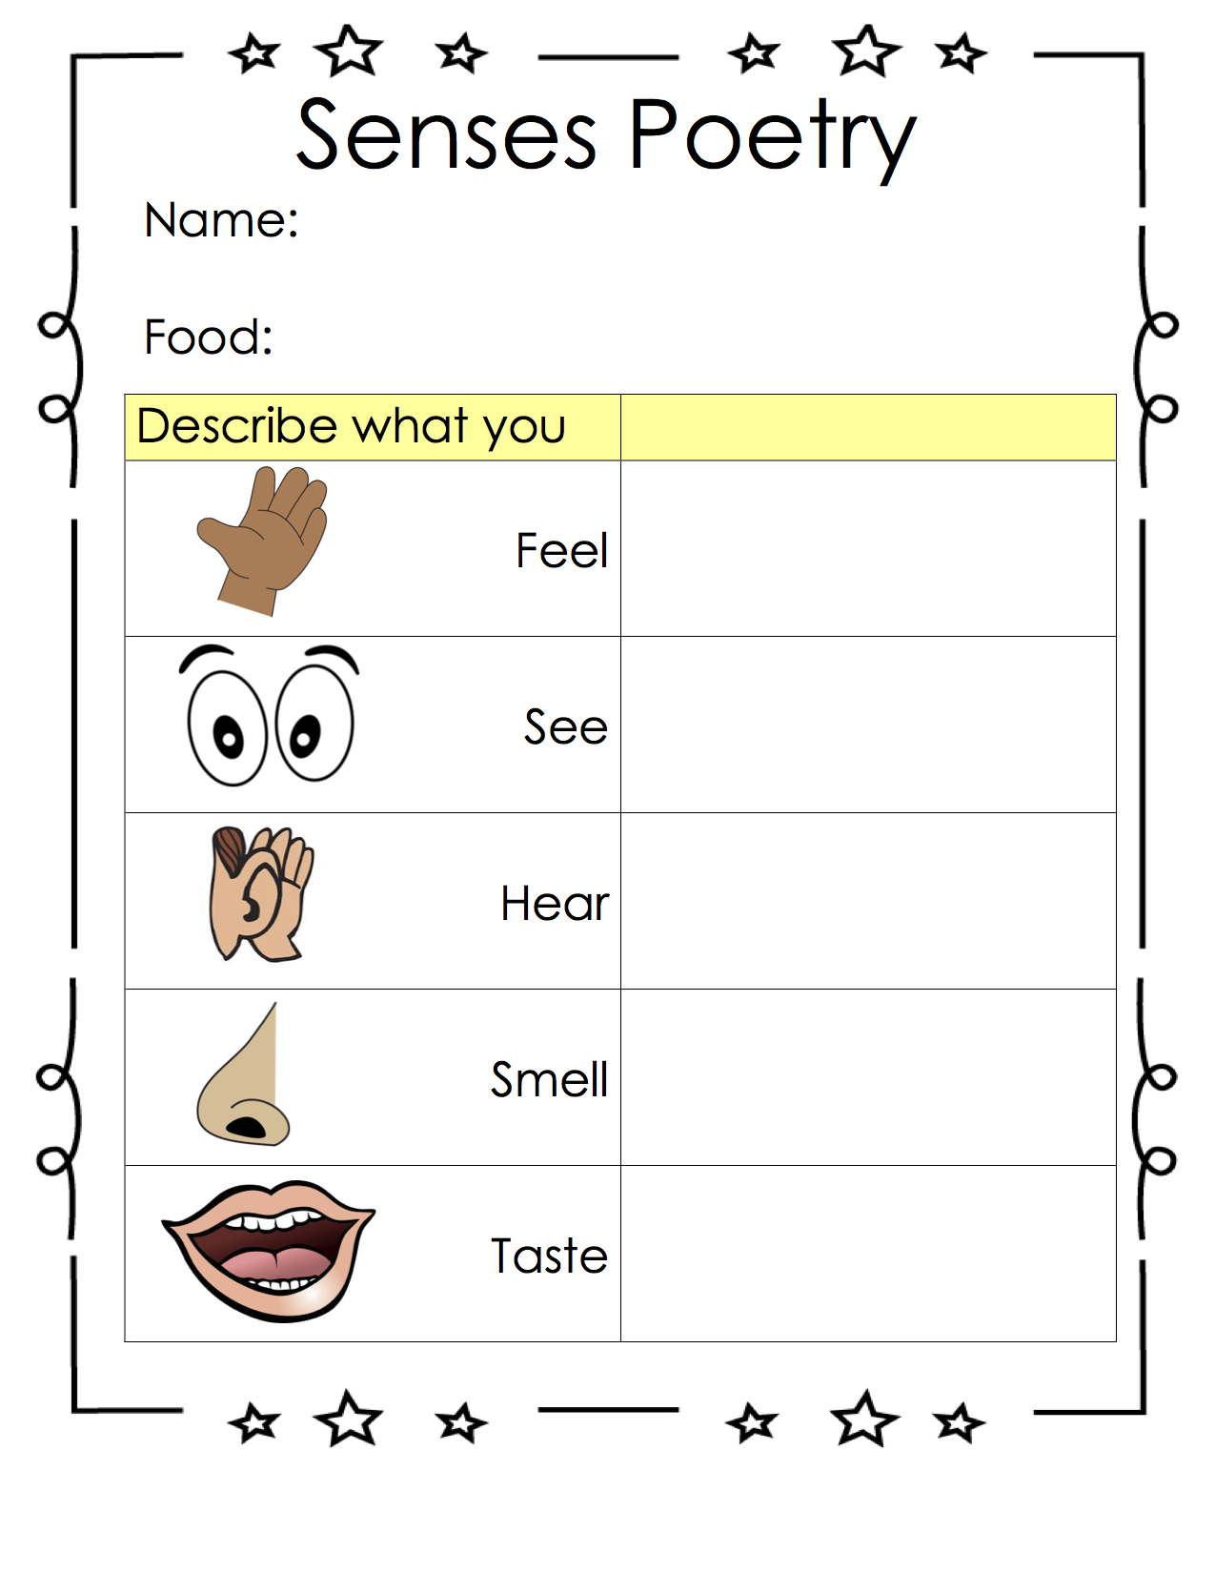

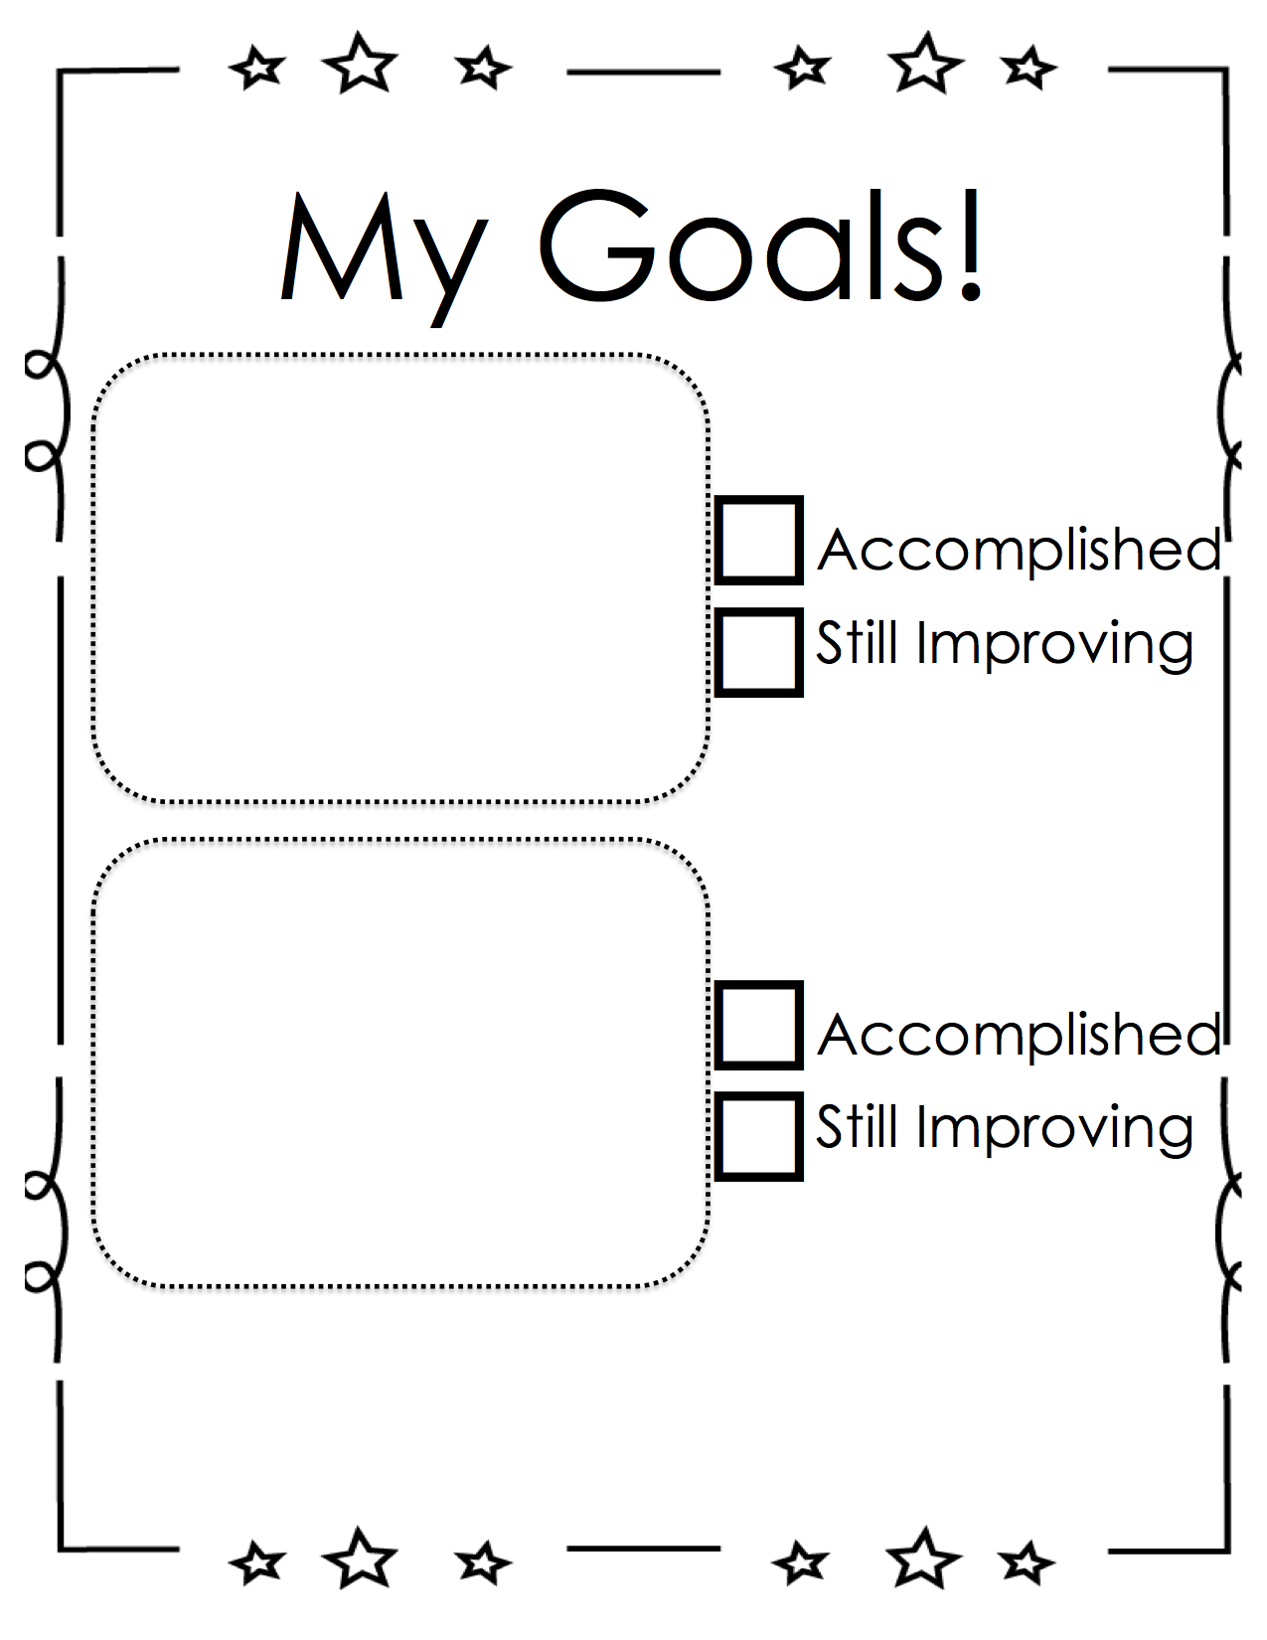

Categories | Level 1 | Level 1 | Level 3 | Level 4
Form | Does not use a poetic form | Somewhat uses a poetic form | Poem follows a poetic form | Poem clearly and effectively follows a poetic form
Word Choice | Uses basic words | Uses mostly basic and some interesting words | Attempts to use interesting words | Uses interesting words that paint a clear picture in the reader’s mind
Voice | There is no feeling in your writing | Little feeling about your topic is expressed | Feeling about your topic is expressed | Strong feelings and emotions about your topic is expressed
Sentences | No evidence of simple sentences | Few simple sentences, sometimes incomplete | Simple, complete sentences | Variety in simple and complete sentences
Spelling | Uses only random letters | Uses some spelling strategies | Uses strategies for spelling | Familiar words are spelled correctly
Capital Letters | No capital letters or in the wrong place | Some use of capital letters | Mostly uses capital letters properly | Uses all capital letters accurately
Periods | No periods are used | Some periods at the end of some sentences | Mostly uses periods properly | Uses periods properly
Visual Presentation | Visual presentation is unclear (spacing, placement, legibility | Visual presentation is basically clear | Clear visual presentation | Clear presentation that enhances the writing.
Poetry Rubric

