Unit 2 – Lesson: 8
Fiction: Pulling It All Together (Publishing)

In this lesson students will consolidate their learning about the writing process. This lesson will focus on putting all their learning together. Students will submit a piece of writing and evaluate it based on the rubric.

Topic: Writing Process- Editing

Time Frame: 60-90minutes

Driving question: What should I see in growing writers’ writing? (What have we learned over the past few weeks?)

Curriculum Outcomes –
9: Students will use a range of strategies to develop effective writing and media products to enhance their clarity, precision and effectiveness.

Learning Target:
Grade 1 | Grade 2
Publish student-selected final pieces of writing that demonstrate grade level traits and conventions | Publish student-selected final pieces of writing that demonstrate grade level traits and conventions

Resources Needed:

- Screencast: https://www.youtube.com/watch?v=7YsOeAVkjZk
- Strips of white paper with reasons people write written on them
- Two Hula hoops
- Access to computers or iPads with familiar apps
- Writing Folder – to store writing at various stages
- Writer’s Notebook - to record ideas and goals for their writing

Lesson:

I Do:
Show the screencast to students. Invite students to turn and talk to a partner about what growing writers can do in their writing. What are some of the things that they have learned so far? What should the teacher see in their writing?
Invite students to share their responses. Record student answers on chart paper, iPads, computer, or interactive whiteboard.

Share the rubric with students and talk about what we would expect to see in our writing. Explain to students that a rubric shows different levels of writing and helps the teacher and the student decide which areas they need to work on. It would be helpful to have writing samples to show students. This is an area that I plan on building up over the year.

We Do:
One of the goals is for students to understand that writer’s write for a variety of reasons. We want students to understand that they aren’t writing just for their teacher, but that as grade one and two students they can write for a variety of purpose.
Beforehand, on strips of white paper, write reasons or purposes for writing. Some of these could include; card making, to make people laugh, to teach someone something, instructions, for TV shows, movies, plays, etc.
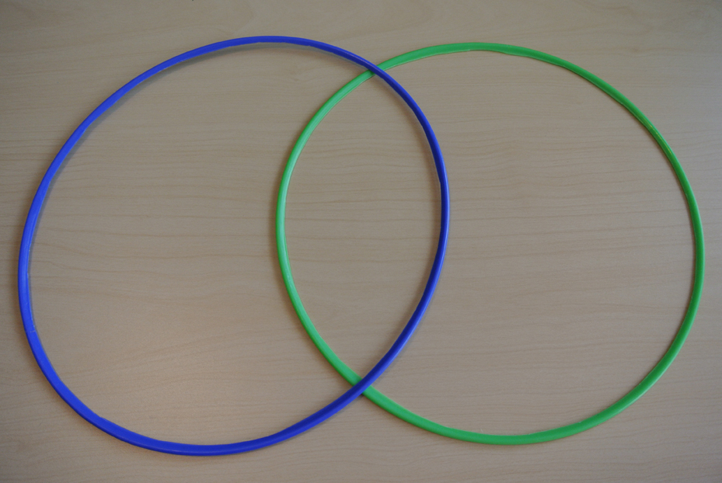
Gather the group on the floor and place the hula-hoops on the floor to create a Venn Diagram. At the top of one circle on white paper write, “Authors” and on top of the other on white paper write, “Students”. Have students sort the strips that you created beforehand. Have them decide if only authors can write for that purpose. if students can write for that purpose, or if both can write for the purpose listed on the paper. The purpose of the activity is for students to realize that they can publish their work for a variety of reasons and in a variety of ways.
Have a discussion with the students about the ways in which they can publish their work and what would be acceptable. Students can use the computer to type up their work, they can use the iPad and an app that they are comfortable with, or they can use pencil and paper to submit their final piece.

You Do:
Students should spend time independently writing. They should work to complete a piece of writing that has gone through the various stages of the process. As students are independently writing, it will be important to conduct one-on-one conferences with students to identify areas of strengths and develop goals for next workshop.

We Share:
Ask students, if they would like, to share a piece of their writing. Using our rubric, have the class evaluate the students writing, careful to talk about the positives and areas of growth. It will be important for students to understand that a finished piece of work does not mean that we can’t take it back and make it even better. Even published authors spend lots of time revising and revising their work. Celebrate all levels of writing and point out in the strengths and provide on the spot feedback specifically about the problem and solution in the story.

Differentiation/Adaptations:

This is embedded into the design of the lesson plan. Students who use an iPad for writing or as a documented adaptation will easily be able to complete this assignment on any app of their choice.

Extensions:

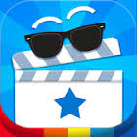
There is an app called, “Toontastic”. It is a fantastic app that leads students through the story writing process. Students who finish early can begin exploring the app to create digital versions of their written stories.

Assessments:

Record observations on students’ prewriting skills in Evernote or however you choose to track your students.
Collect the finished pieces of work. Use the rubric below to evaluate students’ learning.

Fiction Writing Rubric
Categories | Level 1 | Level 1 | Level 3 | Level 4
Ideas | Uses 1 simple idea not connected to your topic | Uses 2-3 ideas that are connected to your topic | Uses 4 ideas connected to your topic | Uses 4 or more ideas connected to your topic
Details | Uses 1 supporting detail | Few supporting details but not enough to make the reader see, feel, hear your description | Uses an increasing number of details. | Uses a variety of details to help the reader see, feel, or hear the description
Voice | There is no feeling in your writing | Little feeling about your topic is expressed | Feeling about your topic is expressed | Strong feelings and emotions about your topic is expressed
Sentences | No evidence of simple sentences | Few simple sentences, sometimes incomplete | Simple, complete sentences | Variety in simple and complete sentences
Spelling | Uses only random letters | Uses some spelling strategies | Uses strategies for spelling | Familiar words are spelled correctly
Capital Letters | No capital letters or in the wrong place | Some use of capital letters | Mostly uses capital letters properly | Uses all capital letters accurately
Periods | No periods are used | Some periods at the end of some sentences | Mostly uses periods properly | Uses periods properly
Visual Presentation | Visual presentation is unclear (spacing, placement, legibility | Visual presentation is basically clear | Clear visual presentation | Clear presentation that enhances the writing.

