Unit 2 – Lesson: 6
Fiction: Problem and Solution

In this lesson students will continue to explore the elements of a story. This lesson will focus on problem and solution. Students will demonstrate an understanding that in fiction writing stories have a problem and a solution.

Topic: Writing Process-Fiction Elements

Time Frame: 60-90 minutes

Driving question: In every fiction story that you read, is there always a problem and a solution?

Curriculum Outcomes –
7: Students will be expected to use writing and other forms of representation including digital to explore, clarify and reflect on their thoughts feeling and experiences and learning

Learning Target:
Grade 1 | Grade 2
Create print and digital texts (draw or write) with a beginning, middle, and end | Write in both print and/or digital format an organized text with a beginning, middle, and end

Resources Needed:
- Problem and Solution worksheet (located below in lesson)
- Cube with situations printed on it (located below in lesson)
- Access to iPads with familiar apps
- Writing Folder – to store writing at various stages
- Writer’s Notebook - to record ideas and goals for their writing

Lesson:

I Do:
Students should have an opportunity to interact with mentor texts for fiction stories. These should be on display in the classroom and explored during shared or independent reading experiences. This is an important step for growing writers.
Choose a book to share with students.
One of my favorite books to talk about is “Chrysanthemum” by Kevin Henkes.
You may share this story with the students.
Or here are a list of picture books that are strong examples of problem and solution.
http://thisreadingmama.com/books-with-problem-and-solution/

We Do:
After reading the story “Chrysanthemum” talk about problem (something that a character in a story wants to change, fix, or figure out) and solution (the way a problem or solution is fixed).
Complete the graphic organizer on problem and solution together.
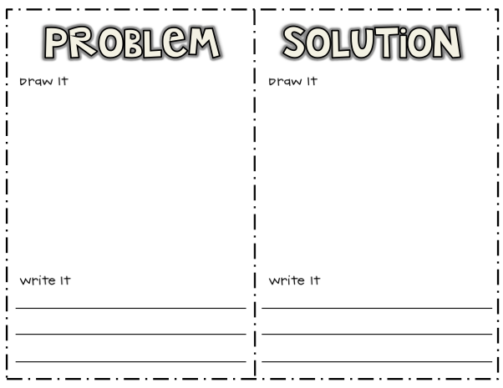

https://www.teacherspayteachers.com/Product/ProblemSolution-Writing-printable-215651

Role Play Activity
There is a cube template below with possible problems on it. Students should be grouped into small groups of 3-4 and each group should get a cube. Students can take turns rolling the cube and talking about a possible solution for each problem. With their partners they can act out each scenario. Once the whole group is brought back together, the teacher can choose a group, roll the cube, and have that group act out the scenario with their solution.

You Do:
Using the ipad, students can take a picture of their favorite fiction books. They can import the picture into pic collage and identify the problem and solution. There is a sample below in the lesson plan based on “Chrysanthemum”.

Students have been working on the many different elements of a story.
“Today we are going to revisit our drafts to make sure that our story has a problem and we have clearly identified the solution.
Students can use their iPads, the computer, or pencil and paper to complete this activity. Students should be encouraged to return to the writing that they started on the previous day. They should examine their writing to see if they have described their problem and developed a solution.
As students are independently writing, the teacher can conference with students one-on-one or in small groups.

We Share:

When students are finishing up we can gather together as a group. Students can have an opportunity to share their writing. Celebrate all levels of writing and point out in the strengths and provide on the spot feedback specifically about the problem and solution in the story.

Differentiation/Adaptations:

This is embedded into the design of the lesson plan. Students who use an iPad for writing or as a documented adaptation will easily be able to complete this assignment on any app of their choice.

Extensions:

There is an app called, “Toontastic”. It is a fantastic app that leads students through the story writing process. Students who finish early can begin exploring the app to create digital versions of their written stories.

Assessments:

Record observations on students’ prewriting skills in Evernote or however you choose to track your students.

You fall and scrape your knee while riding your new bike.
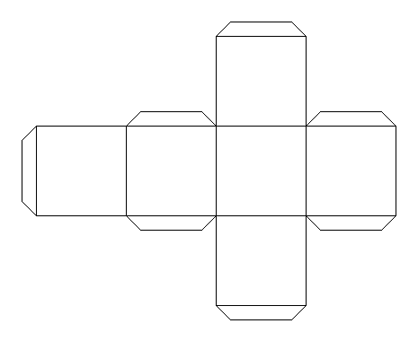

You move to a new school and do not know anyone
Your friend has been playing with a toy for a long time and won’t give you a turn.
You and your best friend got into an argument.
You broke your brother’s favorite toy.
You really want a new iPad or tablet.
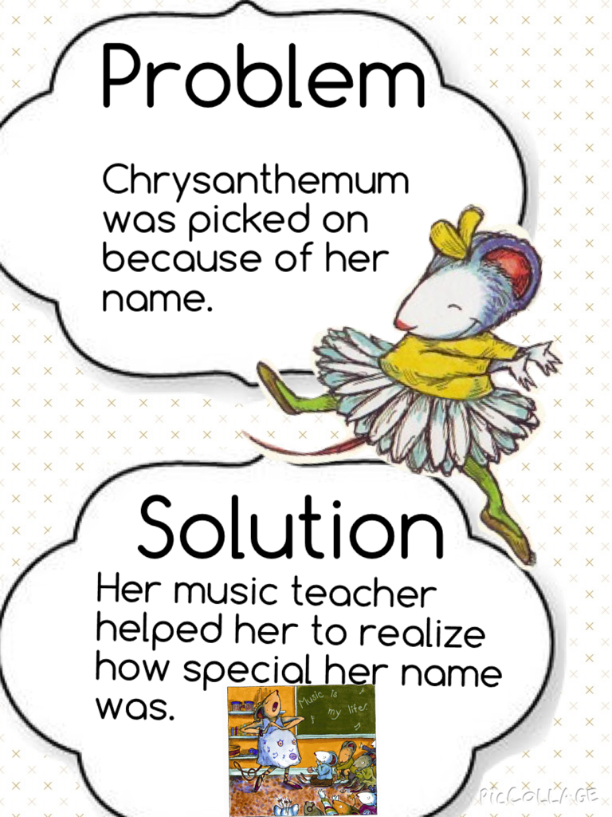
Fiction Writing Rubric
Categories | Level 1 | Level 1 | Level 3 | Level 4
Ideas | Uses 1 simple idea not connected to your topic | Uses 2-3 ideas that are connected to your topic | Uses 4 ideas connected to your topic | Uses 4 or more ideas connected to your topic
Details | Uses 1 supporting detail | Few supporting details but not enough to make the reader see, feel, hear your description | Uses an increasing number of details. | Uses a variety of details to help the reader see, feel, or hear the description
Voice | There is no feeling in your writing | Little feeling about your topic is expressed | Feeling about your topic is expressed | Strong feelings and emotions about your topic is expressed
Sentences | No evidence of simple sentences | Few simple sentences, sometimes incomplete | Simple, complete sentences | Variety in simple and complete sentences
Spelling | Uses only random letters | Uses some spelling strategies | Uses strategies for spelling | Familiar words are spelled correctly
Capital Letters | No capital letters or in the wrong place | Some use of capital letters | Mostly uses capital letters properly | Uses all capital letters accurately
Periods | No periods are used | Some periods at the end of some sentences | Mostly uses periods properly | Uses periods properly
Visual Presentation | Visual presentation is unclear (spacing, placement, legibility | Visual presentation is basically clear | Clear visual presentation | Clear presentation that enhances the writing.

