Unit 2 – Lesson: 7
Fiction: Revising & Editing

In this lesson students will continue to explore the writing process. This lesson will focus on revising and editing. Students will demonstrate an understanding that growing writers make revisions to their story and take the time to edit their stories.

Topic: Writing Process- Revising and Editing

Time Frame: 60-90minutes

Driving question: What is the difference between revising and editing?

Curriculum Outcomes –
9: Students will use a range of strategies to develop effective writing and media products to enhance their clarity, precision and effectiveness.

Learning Target:
Grade 1 | Grade 2
Revision: Recognize where they can make changes to writing to clarify meaning  Editing: use environmental print to check some high-frequency words, begin to add a few grade level conventions | Revision: make changes to writing to clarify meaning through strategies such as; inserting a word, using a caret, crossing out a word, adding details  Editing: use the word wall to check high frequency words, begin to use simple self-editing checklists to edit for conventions

Resources Needed:

- Multiple square tissue boxes and template (from below) printed off and glued onto the tissue boxes.
- Screencast:
Revision: https://www.youtube.com/watch?v=0lrjUfTcJ54
Editing: https://www.youtube.com/watch?v=u1V5YVmFHVk
- Samples of grade level writing
- Access to computers or iPads with familiar apps
- Writing Folder – to store writing at various stages
- Writer’s Notebook - to record ideas and goals for their writing

Lesson:

I Do:
If the previous lessons in unit one were completed before this lesson, students will have experience with revision in organization and word choice lesson. This will be a refresher and build on those skills. It will be important for students to be able to recognize the difference between the revising and editing process. Show the screencast on revision to students. Talk about the importance of revision and making sure that your audience can read and understand your writing.
Show two samples of writing (one that might match a level one piece of writing based on the rubric below, and a level 3 or 4). Have students talk about what both writer’s do well and areas they can improve on.
Ask students if they have ever read a published book that had spelling errors? Words too close together? Was written messy?
“Author’s make sure that the writing that they are publishing and selling is the best work that they can do. If other people are reading their work, the want to make sure that their audience can understand what they have written.”

We Do:
Share the revising poster and the editing posters.
Have students identify the differences between the two different steps.
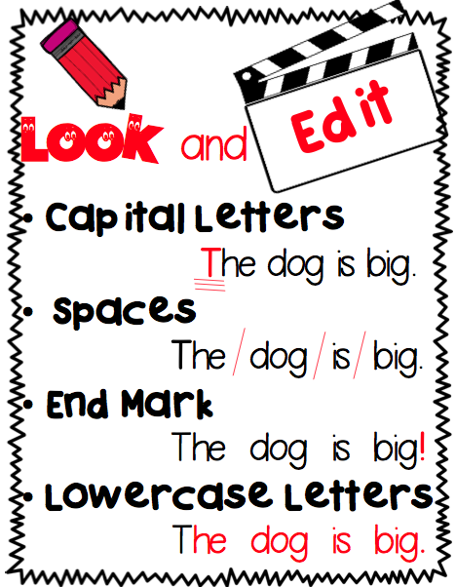
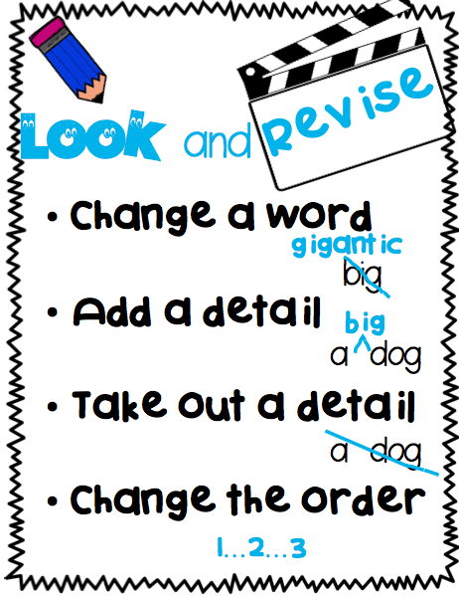
Encourage students to identify somewhere in their writing where they can make a revision and identify where they can make an editing change. Observe whether students can identify the differences between revising and editing. https://www.teacherspayteachers.com/FreeDownload/Revising-and-Editing-Posters-1686669

You Do:
Sentence Editing Activity:
Print off and build the editing cubes from the link below.
In small groups students can take turns rolling the cubes. They should read the sentence they rolled. They should use the iPads, whiteboard, or paper to record the edited sentences.
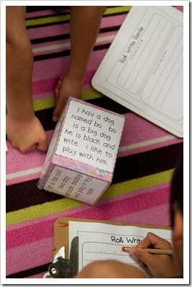
https://drive.google.com/a/gnspes.ca/file/d/0B6zC45cAimWuNTZkOTYxNjgtM2FiMS00YWNhLWI3MDgtZGMyMTE0NzliYmNl/view

Students have been working on the many different elements of a story.
“Today we are going to revising and editing checklists to check our writing. Your finished pieces of writing should look different than your drafts.
Students can use their iPads, the computer, or pencil and paper to complete this activity.

After students complete their story map they should be encouraged to return to the writing that they started on the previous day. They should examine their writing and use the revising and editing checklist to make changes to their writing.
As students are independently writing, it will be important to conference with students one-on-one or in small groups.

We Share:
When students are finishing up we can gather together as a group. Students can have an opportunity to share their writing. Celebrate all levels of writing and point out strengths and provide on the spot feedback specifically about the revising and editing changes that were made.

Differentiation/Adaptations:
This is embedded into the design of the lesson plan. Students who use an iPad for writing or as a documented adaptation will easily be able to complete this assignment on any app of their choice.

Extensions:

There is an app called, “Toontastic”. It is a fantastic app that leads students through the story writing process. Students who finish early can begin exploring the app to create digital versions of their written stories.

Assessments:
Record observations on students’ prewriting skills in Evernote or however you choose to track your students.

Revising and Editing Checklist

Revising
- I used W.O.W words

- My writing is in order

- My sentences are about my topic

- I have a strong beginning

- I have a strong ending

Editing
- My writing goes from left to right
➔ ➔ ➔

- The Word Wall words are spelled correctly

- I have good spacing between my words

- I have capital letters at the beginning of my sentences and for the word “I”

- I have a period at the end of my sentence

Fiction Writing Rubric
Categories | Level 1 | Level 1 | Level 3 | Level 4
Ideas | Uses 1 simple idea not connected to your topic | Uses 2-3 ideas that are connected to your topic | Uses 4 ideas connected to your topic | Uses 4 or more ideas connected to your topic
Details | Uses 1 supporting detail | Few supporting details but not enough to make the reader see, feel, hear your description | Uses an increasing number of details. | Uses a variety of details to help the reader see, feel, or hear the description
Voice | There is no feeling in your writing | Little feeling about your topic is expressed | Feeling about your topic is expressed | Strong feelings and emotions about your topic is expressed
Sentences | No evidence of simple sentences | Few simple sentences, sometimes incomplete | Simple, complete sentences | Variety in simple and complete sentences
Spelling | Uses only random letters | Uses some spelling strategies | Uses strategies for spelling | Familiar words are spelled correctly
Capital Letters | No capital letters or in the wrong place | Some use of capital letters | Mostly uses capital letters properly | Uses all capital letters accurately
Periods | No periods are used | Some periods at the end of some sentences | Mostly uses periods properly | Uses periods properly
Visual Presentation | Visual presentation is unclear (spacing, placement, legibility | Visual presentation is basically clear | Clear visual presentation | Clear presentation that enhances the writing.

