Unit 3 – Lesson 1
Poetry: What is a Poem?

In this lesson students will explore poetry. This lesson will focus on introducing variety of poems and place them into categories based on similarities and differences.

Topic: Poetry

Time Frame: 60-90minutes

Driving question: What is a Poem?

Curriculum Outcomes –
6: Students will convey meaning by creating print and digital texts collaboratively and independently using imagination, personal experiences, and feelings.
8: Students will be expected to create text including digital collaboratively and independently using a variety of forms for a range of audiences and purposes.

Learning Target:
Grade 1 | Grade 2
Understand that writing and other forms of representing convey meaning | Begin to choose forms of writing that are appropriate to specific purposes and audiences

Resources Needed:

- Collection of poetry books and poems
- Access to computers or iPads with familiar apps
- Writing Folder – to store writing at various stages
- Writer’s Notebook - to record ideas and goals for their writing

Lesson:

I Do:
Students should have an opportunity to interact with a variety of poetry forms and texts. These should be on display in the classroom and explored during shared or independent reading experiences. It is an important step for growing writers to read good mentor texts.
“When we begin to write our poetry, we are going to use a rubric to help us think about all of the things that we need to include. Today we are going to look at the rubric and see there are things on the rubric that you think that you can already do or if there are things that might become a writing goal for you.”
Explore the rubric with students and discuss areas of strengths and areas for improving.

We Do:
Share a variety of poems with students in a shared reading experience. I have created a mimio file for my class with poems that I will read out loud or we will read together. It can be found here as a PDF. After we have read the poems together, have students turn and talk to a partner about the things they notice about poetry. Create an anchor chart with the students based on what they notice and think poetry is. This chart can be on display in the classroom throughout the poetry unit. I created a sample chart below. Remind students that growing writers write about what they know and love. Ask students, “Where do you think writer’s get their ideas? What do you think their poems are about?”
Provide students with printed out versions of the poem. In small groups or a whole group, have the students try and sort the poems. Can they make categories? What title would they give each group they created?

You Do:
Students should spend time independently writing. Students should choose a topic that they feel strongly about and spend time drawing and writing about it. Remind students that they are to use the steps in the writing process and to think about the traits of writing. As students are independently writing it will be important to conference with students one-on-one or in small groups. As we get further into the poetry unit students will be exploring different poetry forms with graphic organizers. They will be encouraged to write using one of these forms. The continued practice of free writing about feelings, emotions, or experiences is an important step to poetry writing.

We Share:
When students are finishing up we can gather together as a group. Students can have an opportunity to share their writing they completed independently. Remind students that poetry may be about many different things and usually have a strong feeling or emotion attached to them. Encourage students to give one another feedback about the feeling or emotions in their writing. Revisit the poetry rubric to see if we can identify areas of strength and areas of growth.

Differentiation/Adaptations:
This is embedded into the design of the lesson plan. Students who use an iPad for writing or as a documented adaptation will easily be able to complete this assignment on any app of their choice.

Assessments:
Record observations on students’ prewriting skills in Evernote or however you choose to track your students.
Have students complete a reflection (exit pass) about what they think a poem can be.

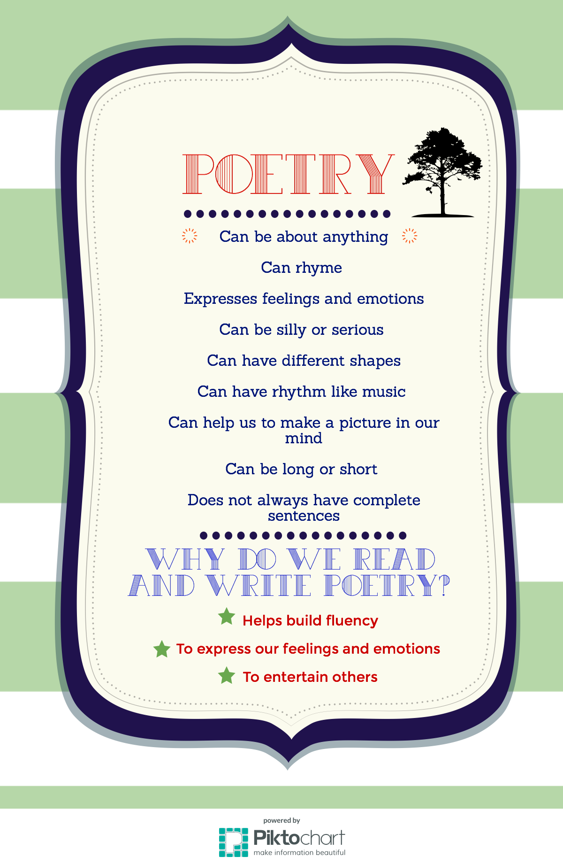

Name:

Poetry Lesson 1: Exit Pass

Tell me what you think a poem is.

Name:

Poetry Lesson 1: Exit Pass

Tell me what you think a poem is.

Categories | Level 1 | Level 1 | Level 3 | Level 4
Form | Does not use a poetic form | Somewhat uses a poetic form | Poem follows a poetic form | Poem clearly and effectively follows a poetic form
Word Choice | Uses basic words | Uses mostly basic and some interesting words | Attempts to use interesting words | Uses interesting words that paint a clear picture in the reader’s mind
Voice | There is no feeling in your writing | Little feeling about your topic is expressed | Feeling about your topic is expressed | Strong feelings and emotions about your topic is expressed
Sentences | No evidence of simple sentences | Few simple sentences, sometimes incomplete | Simple, complete sentences | Variety in simple and complete sentences
Spelling | Uses only random letters | Uses some spelling strategies | Uses strategies for spelling | Familiar words are spelled correctly
Capital Letters | No capital letters or in the wrong place | Some use of capital letters | Mostly uses capital letters properly | Uses all capital letters accurately
Periods | No periods are used | Some periods at the end of some sentences | Mostly uses periods properly | Uses periods properly
Visual Presentation | Visual presentation is unclear (spacing, placement, legibility | Visual presentation is basically clear | Clear visual presentation | Clear presentation that enhances the writing.
Poetry Rubric

